**“STYLE SPARKS”**

**“Stand out in style”**

**Submitted by**

Miss Trupti kunnurkar U15BL22S0030

Miss Samiksha Patil U15BL22S0036

Miss Riya Goje U15BL22S0043

**Under the guidance of**

**Prof. Ramabhau S. Huddar**



**S.K.E SOCIETY’S**

**GSS COLLEGE,DEPARTMENT OF BCA**

**Tilakwadi, Belagavi-590006**

**Affiliated to Rani Channamma University, Belagavi.**

**2024-2025**

* **Intoduction**
* **Project Title**

Ecommerce Customized T-shirt, Hoodies, Bags, Phone cover and Book cover Design System

* **Category**

Ecommerce/custom Apparel Design

* **Overview**

This system provides an online platform for users to design and purchase customized products. It integrates functionalities for administrators, vendors, and end-users to manage, create, and order personalized T-shirt, Shirt, Hoodies, Bags, Phone cover, Book cover

* **Objectives of the System**
* **Low Investment**: This refers to the need for minimal financial resources to start or run a business or venture
* **Minimum Risk**: Minimum risk means the potential for loss or failure is kept to a low level
* **Scalability**: Scalability refers to the ability of a business or operation to grow and handle increased demand without being hampered by its structure or available resources.

* **Global Reach**: This indicates the ability of a business or product to serve a worldwide market.
* **Automation**: Automation refers to using technology to perform tasks without human intervention
* **Eco-friendly**: Eco-friendly businesses or products have a minimal impact on the environment.
* **Focus on Creativity**: Businesses that focus on creativity often emphasize innovation, unique problem-solving, and artistic expression.
* **Scope of the System**
* **E-Commerce Growth**: The rise of online shopping, digital marketplaces, and the increasing preference for convenience have driven significant growth in the e-commerce sector.
* **Wide Product Range**: E-commerce businesses often offer a broad selection of products across various categories, allowing them to cater to diverse customer needs.
* **No Inventory Management**: This is particularly true for businesses that adopt the drop shipping model.
* **Global Market Access**: E-commerce businesses can reach customers across the world, expanding their market beyond geographical constraints.
* **Scalable Business**: E-commerce businesses, particularly those based on digital platforms, are highly scalable.
* **Low Startup Cost**: Starting an e-commerce business typically requires much less capital than traditional brick-and-mortar businesses. tools or infrastructure.
* **Drop shipping Model**: In a drop shipping model, the retailer does not keep products in stock. Instead, when an order is made, the retailer purchases the product from a third-party supplier who ships it directly to the customer.
* **SRS Requirements**

1. **Software Requirements:**

* Operating System: Windows 11.
* Programming language: PHP 5.6, PHP 7 for server-side scripting.
* User Interface Design: HTML, CSS, JAVASCRIPT
* Database: My SQL 5.x
* Web Browser: Google chrome
* Software: XAMPP

1. **Hardware Requirements:**

* Processor: 11th Gen Intel(R) Core (TM) i3-1115G @3.00GHz 2.90G
* RAM: 8.00 GB
* System type: 64-bit operating system, x64 based processor
* Processor Edition: Windows 11 home single language
* Version: 24H2
* Hardware disk: 10GB
* **Description of Programs**
* **Data Flow Diagrams (DFDs)**

**Level 0 DFD (Context Diagram)**: Shows the system as a single process and its interaction with external entities.

* **Process**: Ecommerce Customized T-Shirt Design System
* **Entities**: Admin, Vendor, User
* **Data Flows**: User data, design information, orders, and payment

**DATA FLOW DIAGRAMS**

Level-0

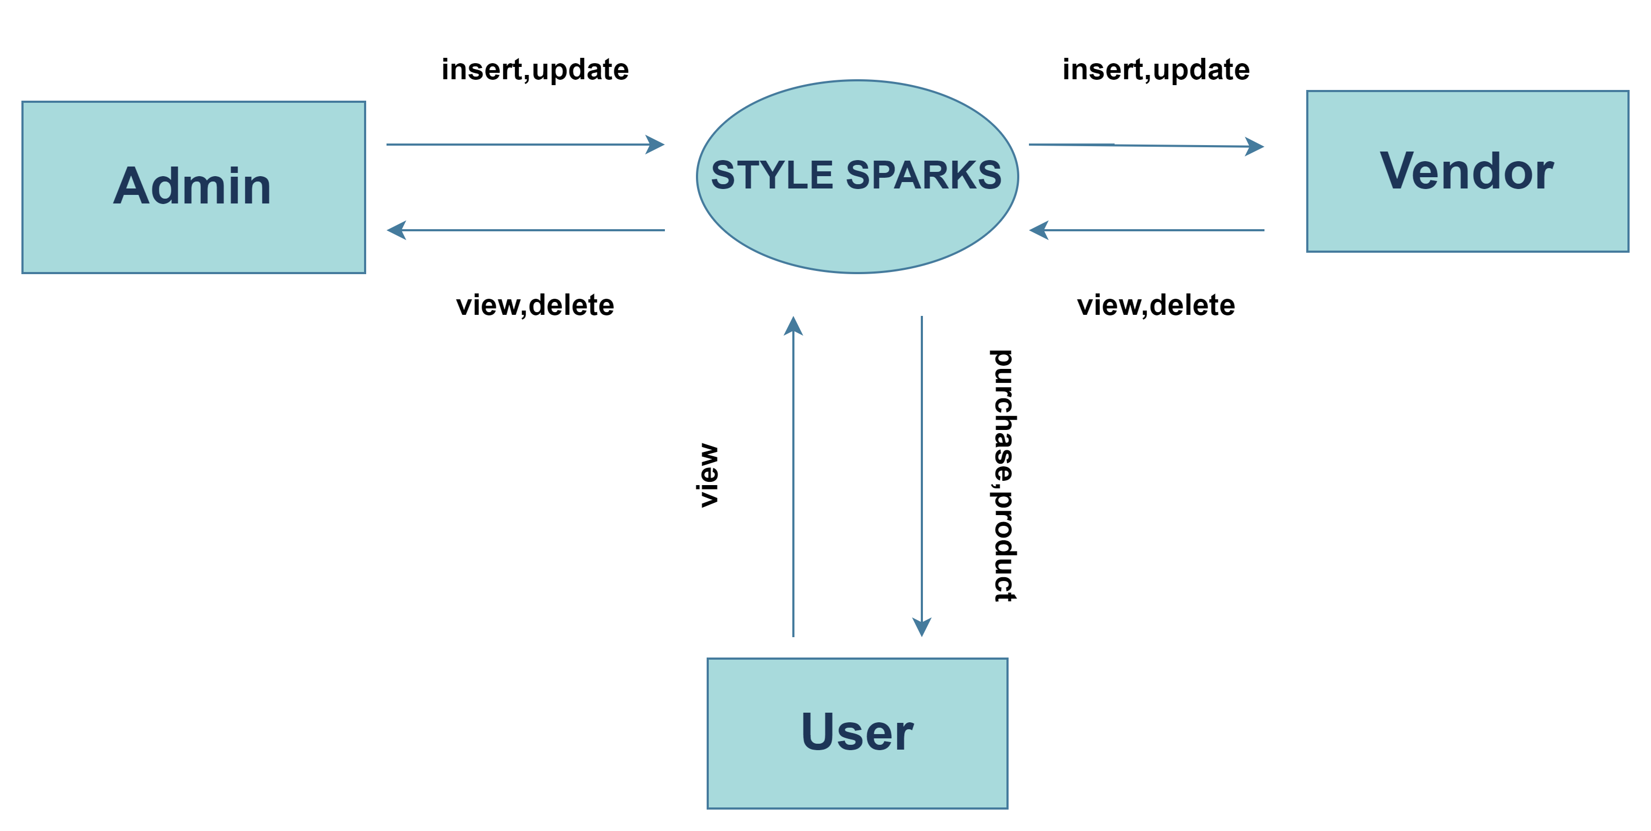

**Level 1 DFD**: Breaks down the system into major modules and their interactions.

* Processes:
  + **Admin Module**: User Management, Vendor Management, Order Management, System Configuration
* **Vendor Module**: Design Management, Order Processing, Inventory Management
* **User Module**: Design Customization, Order Placement, Order Tracking
* **Data Stores**: User Data, Vendor Data, Design Data, Order Data.

**DATA FLOW DIAGRAMS**

Level-1

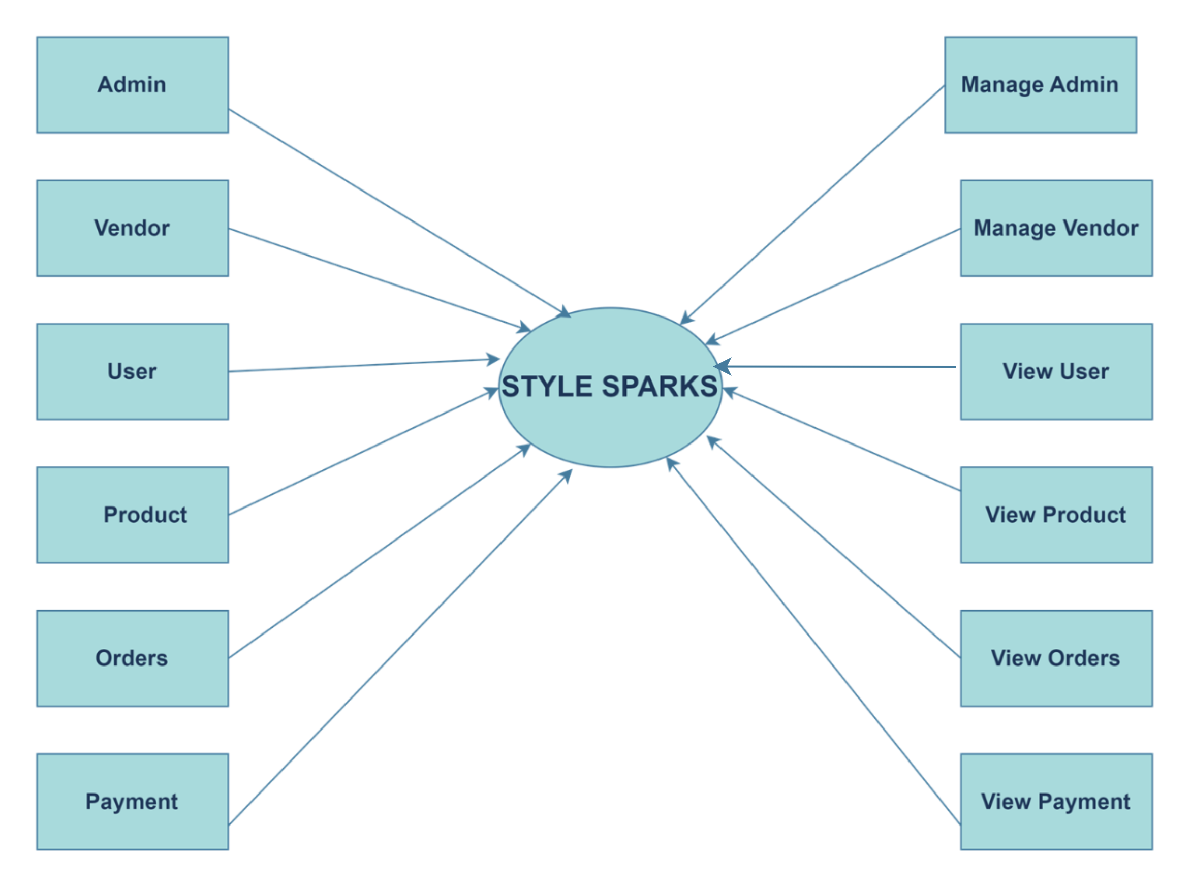

**Level 2 DFD**: Provides a detailed view of processes within each module.

* **Admin Module:**
* **User Management Process**: Handles user data creation, modification, and deletion.
* **Vendor Management Process**: Manages vendor data and approval processes.
* **Order Management Process:** Processes and tracks orders, handles returns.
* **Vendor Module:**
* **Design Management Process**: Manages design data and updates.
* **Order Processing Process:** Handles order fulfillment and status updates.
* **User Module:**
* **Design Customization Process**: Allows users to create and save customized designs.
* **Order Placement Process**: Manages cart and payment processing.
* **Order Tracking Process**: Provides tracking information and status updates

**DATA FLOW DIAGRAMS**

Level-1

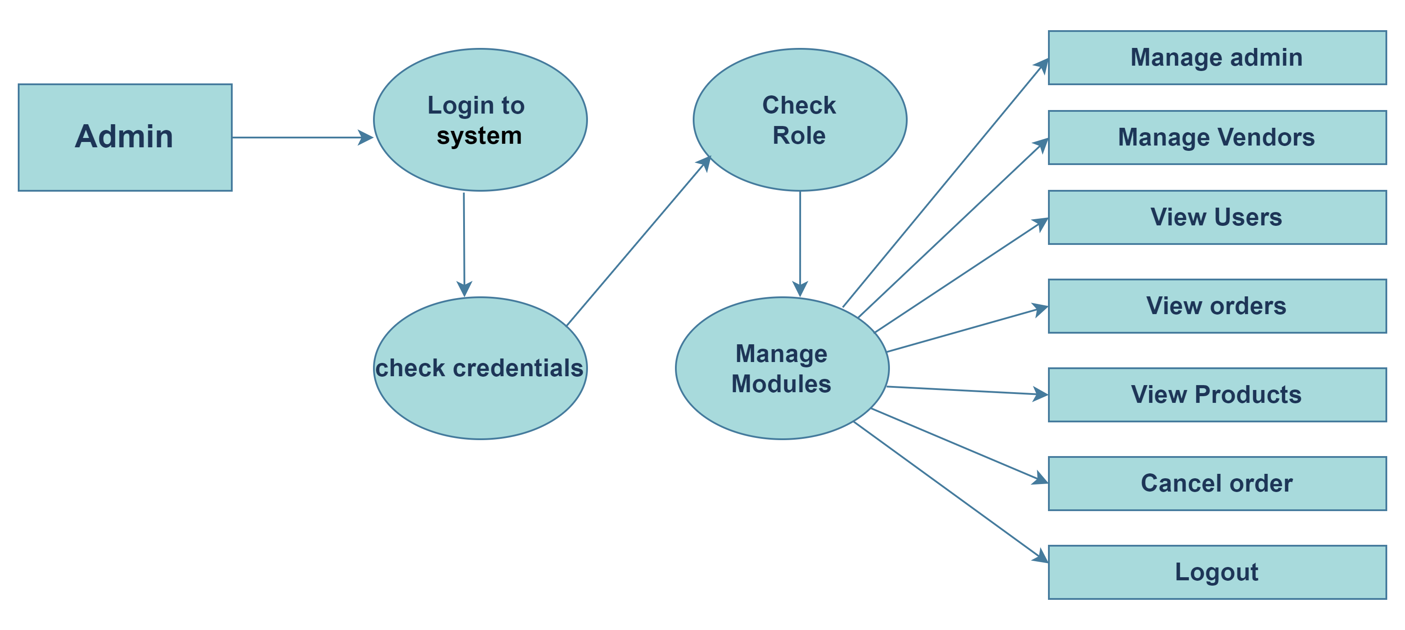

**Class Diagram**

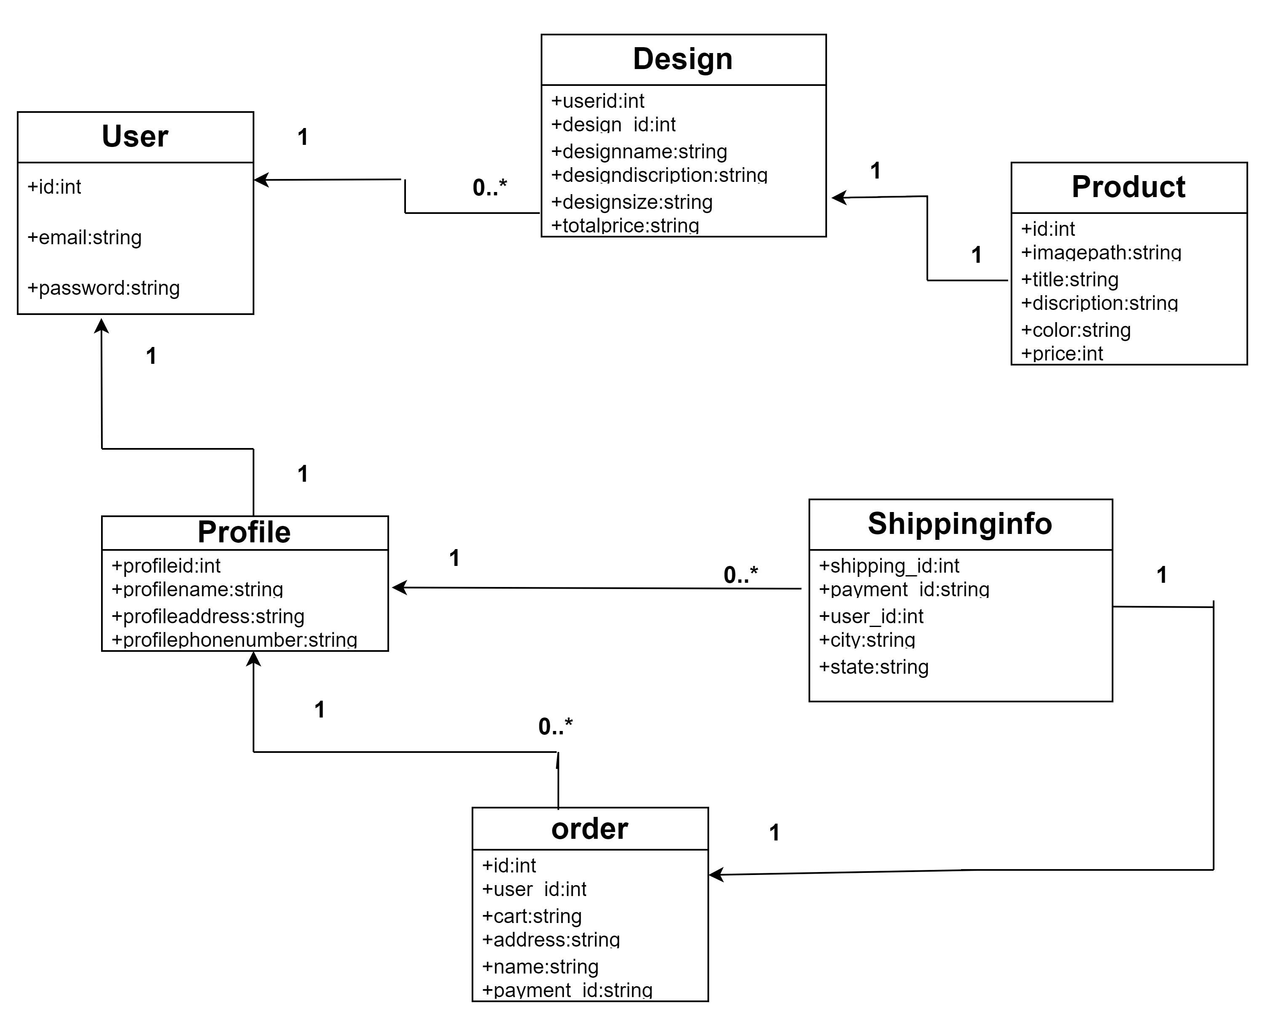

**Modules**

* **Admin Module:**
* User Management: Handles creation, modification, and deletion of user accounts.
* Order Management: Processes and tracks orders, handles returns and refunds.
* System Configuration: Manages system settings, payment gateways, and notification.
* **Vendor Module:**
* Design Management Process: Manages design data and updates.
* Order Processing Process: Handles order fulfillment and status updates.
* **User Module:**
* Design Customization: Allows users to create and customize T-shirts, mugs, mobile, etc.
* Order Placement: Manages cart, payment options, and order completion.
* Order Tracking: Provides order status updates and tracking information.
* **Limitation**
* **Lower Profit Margins** - Since products are printed individually, production costs are higher than bulk printing, reducing profit per sale.
* **Limited Customization** - Most POD services have restrictions on product customization, such as limited printing areas or color options.
* **Longer Fulfillment & Shipping Times** - Unlike bulk orders, each product is printed only after a customer orders it, leading to longer production and delivery times.
* **Quality Control Issues** - Since you don't handle the printing, you rely on the POD provider's quality, which can vary between batches or providers.
* **Limited Product Range** - Not all POD platforms offer the same variety of products, and some niches may have fewer customization options.
* **Dependence on Third-Party Providers** - You don't control production, shipping, or stock, meaning any delays ice changes, or service ↓ disruptions affect your business.
* **Future Scope**
* **Expansion of Product Offerings**-More customizable products, including electronics, home decor, and accessories.
* **Faster Production & Delivery**-Advanced automation and Al-driven fulfillment to reduce turnaround times.
* **Sustainability & Eco-Friendly** -Printing Growth in sustainable materials and eco-friendly inks More POD services adopting ethical and green manufacturing practices.
* **Al & Personalization**-Al-driven design tools for unique, auto-generated artwork.
* **Integration with Emerging Technologies**-Augmented Reality (AR) to let customers visualize designs on products before purchasing.